COUNSELOR’S CORNER

The Leader in Me
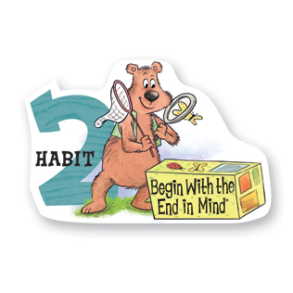
Begin With
the End in Mind

I plan ahead and set goals. I do things that have meaning and make a difference. I am an important part of my classroom and contribute to my school’s mission and vision. I look for ways to be a good citizen.

Becoming Leaders at Heritage!
We have had an exciting start to the year learning about the 7 Habits of Happy Kids. To kick off the year, we held an assembly to introduce the Habits to the students. Every teacher and staff member participated in a skit to demonstrate one of the habits. It was a fun and exciting event! So far, the students have learned about the first two habit in their classrooms: 1) Be Proactive and 2) Begin with the End in Mind.

My lessons during the month of October will focus on Habit 2: Begin with the End in Mind. We will learn about being a leader by planning ahead, participating in activities that make a difference, and being a good citizen. I hope that your student has been talking about the Habits at home!
3rd Grade Fall OAA Testing
Mark your calendars for Monday, October 7th. All third graders will be taking the Ohio Achievement Assessment in Reading. This is an important measure of what our students are learning and how we are doing as a school. We have all been working very hard and learning a lot. So, it is very important that your child be present and feels good on the day of the test. Below are some tips to help prepare your child for the test:

- Get extra sleep the week before the test.
- Eat a healthy breakfast on test day. Avoid sugary foods/drinks.
- Build your child’s confidence. Be encouraging and remind your student of how hard he/she has worked.
- Help your child reduce any test anxiety by encouraging positive thinking.
- Arrive on time for school
- Wear comfortable clothes.
College & Career Family Night
I want to invite everyone to College and Career Family Night on October 1st at Pickerington Central HS from 6-8:40pm. This event is brought to you by PLSD School Counselors. There will be programs for all ages from Kindergarteners up to adults. It's never too early to start preparing for your child's future. See the attached flier about the event. I hope to see you there! Also, Tuesday, October 1st is "Gear up for the Future Day." Students and staff should wear their favorite College gear to school!

Parents! Don’t forget to print the bookmark for you students!
Tessa Gossett, School Counselor
tessa_gossett@plsd.us
http://heschoolcounseling.weebly.com/
614-833-6385

