COUNSELOR’S CORNER

The Leader in Me
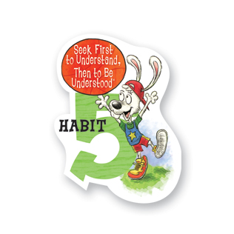
Seek First to Understand, Then to Be Understsood
I listen to other people’s ideas and feelings. I try to see things from their viewpoints. I listen to others without interrupting. I am confident in voicing my ideas. I look people in the eyes when talking.

January Class Lessons: To start off the new year of 2014, we will review Habit 5: Seek First to Understand, Then to Be Understood. We will learn about being a leader by listening to others’ ideas, seeing things from others’ viewpoints, listening without interrupting, voicing ideas confidently, and looking people in the eyes while talking. Listening before we talk is an important communication skill that can be a challenge even for adults. Learning the habit now will help our students succeed in school and in the real world!

Small Groups: We just completed 8 different small groups here at Heritage. It was a great opportunity for the students who were involved and I enjoyed working with each and every one of them. I will continue to offer lunch bunches for 1st- 4th graders. These groups meet once a week for 6-8 weeks during lunch/recess on a variety of topics, including: Anger, Divorce/Family Changes, Anxiety, Friendship, Leadership, and others. The goal of the groups is to learn more about the topic, learn that other kids are in similar situations, and to have a safe place to talk about the topic. If you would like for your child to have an opportunity to participate in one of these groups, please let me know!
Winter Coats: During our coat drive in December, we collected many coats and other winter items. As the need for coats is great this time of year, please feel free to donate any new or gently used winter items (coats, hats, gloves, scarves) anytime throughout the school year. We will make sure that the donated items get to a student in need.

Community resources:
Fairfield County 211- general assistance (740) 687-0500
Hands on Central Ohio (Franklin Co. 211) (614) 221-6766
Pickerington Food Pantry (614) 834-0079

Parents! Don’t forget to print the bookmark for you students!
Tessa Gossett, School Counselor
tessa_gossett@plsd.us
http://heschoolcounseling.weebly.com/
614-833-6385

