COUNSELOR’S CORNER

The Leader in Me
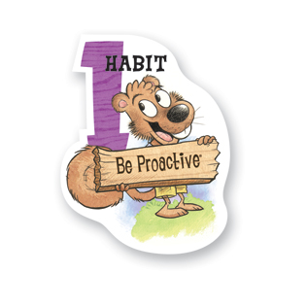
You're in Charge
I am a responsible person. I take initiative. I choose my actions, attitudes, and moods. I do not blame others for my wrong actions. I do the right thing without being asked, even when no one is looking.

Welcome Back to School!
I am excited to be back at Heritage Elementary for my second year! I had a wonderful experience last year and am looking forward to seeing and working with the students again.
As the counselor, I am very excited about the direction our school is headed this year as we implement the Leader in Me program! It is our goal to teach and instill principles of leadership so the students will be enabled to live happy, productive, and successful lives. You will be hearing much about the following habits from the school and your child as he/she learns about them:
- Be Proactive
- Begin With the End in Mind
- Put First Things First
- Think Win-Win
- Seek First to Understand, Then Be Understood
- Synergize
- Sharpen the Saw
While my class lessons will focus on one of the 7 Habits each month, the mission of the Heritage Elementary School Counseling Program will remain the same- To meet the academic, personal/social, and career developmental needs of every student. It is my goal to help students achieve their potential through a variety of services including:
- Classroom Lessons
- Small Group Counseling
- Individual Counseling
- Bucket Filling Program

Please contact me with any questions or concerns you may have. I am here to serve the students and will help you in any way that I am able. I am excited to begin our journey to discover and develop the leader within each and every student!

*See my website for more detailed information about the counseling program!
Parents! Don’t forget to print the bookmark for you students!
Tessa Gossett, School Counselor
tessa_gossett@plsd.us
http://heschoolcounseling.weebly.com/
614-833-6385

