COUNSELOR’S CORNER
The Leader in Me
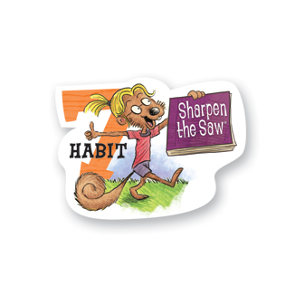
Sharpen the Saw
Balance Feels Best

I take care of my body.
I spend time with family and friends. I learn in lots of different ways. I help others in meaningful ways.

April Class Lessons: This month, we will focus on Habit #7: Sharpen the Saw. It is important for us to find balance in our lives. Habit #7 teaches us to: Take care of my body by eating right, exercising and getting sleep. Spend time with family and friends. Learn in lots of ways and lots of places, not just at school. Find meaningful ways to help others.

OAA Date Change: Attention 3rd and 4th grade parents- Due to our numerous calamity days, the district has changed the dates for the spring OAA for 3rd and 4th graders. Below is the updated schedule:
- Tuesday, April 29th- Reading OAA
- Wednesday, April 30th- Math OAA

Testing Tips: Help prepare your child to do his/her best on the OAA test. This is an opportunity for each student to show how much he/she has grown and learned this year in school!
- Get plenty of sleep the week before the test. It is recommended that elementary school children get 10-12 hours of sleep per night.
- Eat a healthy breakfast the morning of the test. Avoid sugary foods and drinks.
- Wear comfortable clothes. Layers are helpful in case a child gets too warm or cool.
- Practice positive self-statements like, “I can do my best”, “I am smart”, or “I have worked hard this year”. A little encouragement can go a long way!

Free Digital Danger Parent Workshop: Join us on the evening of Tuesday, May 6th, for an important and FREE workshop with the authors of Digital Danger: If You Think Your Kid is Safe Online, Think Again. It is a fast-paced interactive workshop as Dr. Tim Conrad and Officer Don Stanko share strategies to help students and parents stay safe in a digital world. The first 25 Heritage parents to attend will receive a free copy of the book! Information about the time and location of the workshop will be sent home with your child in April.

4th Annual iRun for Jonah: Mark your calendars for Sunday, May 18th! Heritage Elementary is excited to be a part of supporting this important community event! This year, the event will support one of our very own students- Gabe Nutter- who is undergoing treatment for leukemia. Below is a list of ways we can get involved!
- Register for the Walk/Run. Online registration will soon be available at the website: irunforjonah.com. Also, you can fill out a registration form at Heritage Elementary. Registration is $10.
- Buy a t-shirt. We will be pre-ordering t-shirts at Heritage Elementary and Diley Middle School April 7th-18th. T-shirts are $10 and ALL the money goes to Gabe’s family.
- Barnes & Noble Event on April 12 starting at 11am. Enjoy some fun activities with your family.

Community resources:
Fairfield County 211- general assistance (740) 687-0500
Hands on Central Ohio (Franklin Co. 211) (614) 221-6766
Pickerington Food Pantry (614) 834-0079
Parents! Don’t forget to print the bookmark for you students!
Tessa Gossett, School Counselor
tessa_gossett@plsd.us
http://heschoolcounseling.weebly.com/
614-833-6385

